Dunedin Study Findings: The Importance of Identifying Personality Types at a Young Age, by Kirsteen McLay-Knopp
JUNE 30, 2016 / KIRSTEENELAINE
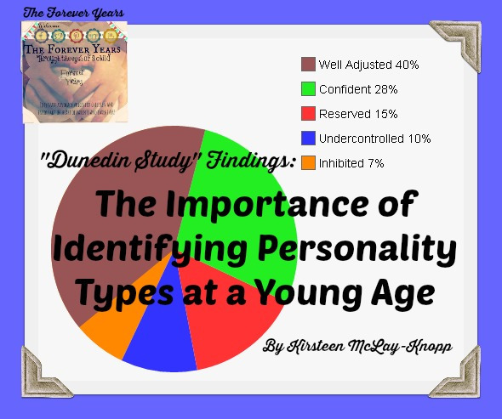Continuing our series of articles on findings discovered by the “Dunedin Longitudinal Study”…
“The Dunedin Study“ identifies five major personality types. These can be recognised in children as young as three years of age and do not change as we grow older: they are the personality types we are born with, they seem to be “in our blood”.
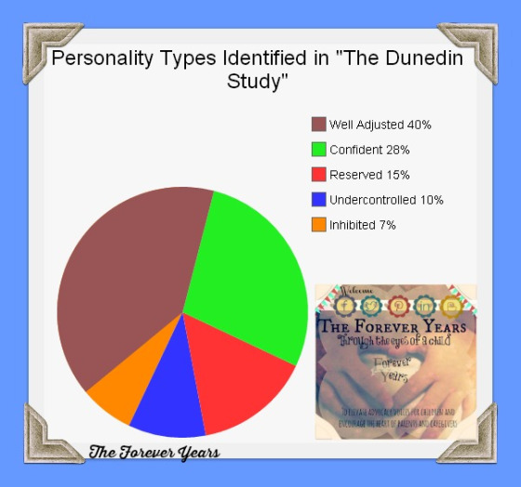
Most people fall into the groups classified as “Well Adjusted”, “Confident”,”Reserved” or some combination of these three: together these three groups cover 83% of the population. “Well Adjusted” individuals tend to fit in with their surroundings, sometimes being “in the lime light”, but not having to all the time. They tend to be able to “get along” with others, for the most part. “Confident” individuals are the risk takers and “go getters”. Like those described as “Well Adjusted” they don’t necessarily always have to be in the limelight, but they are thrill seekers and will “go out on a limb” to try a new idea. An example used in the documantary about “The Dunedin Study” findings, “Why Am I?” was New Zealand’s A.J Hackett, founder of “Bungy Jumping”.
Alan John “A. J.” Hackett is a New Zealand entrepreneur who popularised the extreme sport of bungy jumping. He made the famous bungy jump from the Eiffel Tower in 1987 and founded the first commercial bungy site in 1988.Wikipedia
Those classified as “Reserved” make up 15% of the general population. Reserved individuals tend to “hang back” and watch things for a bit first, before getting involved. They are often a little shy and are more comfortable in smaller groups. These traits do not, however, prevent them living full and productive lives.
According to “The Dunedin Study” monitoring of 1037 people born in 1972-3, “Well Adjusted”, “Confident” and “Reseved” individuals, 83% of the population, usually go on to have “successful life outcomes”. By their 40s they are usually happily married or in positive relationships, are persuing careers and/ or parenting well. The remaining 17% consists of two personality types (again, identifiable in early childhood) which go on to adult lives which create immense angst and unhappiness– both for themselves and for the rest of the community.

Source: Google images.
People with a personality type described in “The Dunedin Study” as “Undercontrolled” are usually highly strung and don’t cope well with novelty or change. These individuals are usually quick to anger and struggle with self control. (Self control was discovered by “The Dunedin Study” to be one of the biggest indicators of a successful life outcome, a characteristic which was even more important than a high IQ). Children identified as being in the “Undercontrolled” personality group at age three were more likely to go on become adults with diabetes, sexually transmitted diseases, heart disease and lung problems.

Source: Google images.
These same adults, despite disliking change or novelty, were described as “impulsive” and “sensation seekers”. They were more likely to drink, take drugs and/ or have sex at an early age and to manifest other behaviour which takes a toll on physical and emotional well-being over time. Children identified as being in this category at age three were highly likely to have been in serious trouble with the law by the time they were 23.
The other 7% of the population have personalities classified, according to “The Dunedin Study” as being “Inhibited”. These individuals do not usually commit crimes or become violent. They seem, instead, to “turn inward on themselves” and what may initially manifest as shyness or social awkwardness in a pre-school child becomes extreme self-consciousness to the point where, in many cases, teenagers manifest “school refusal” ( a refusal to go to school which differs from truancy, in that it is an anxious/ depressive reaction to school, rather than a rebellious act against going to school). Teaching in High Schools in Japan for five years, I saw a number of examples of this, the Japanese call it Hikikomori.
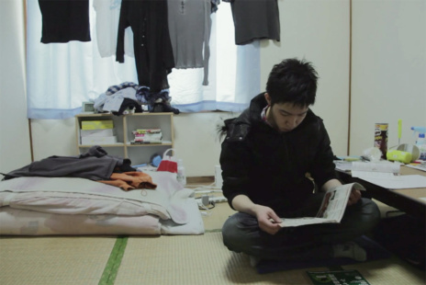
Source: http://hypebeast.com/2015/1/hikikomori-a-deafening-silence-documentary-interviews-japans-social-recluses
Hikikomori (ひきこもり or 引き籠もり Hikikomori, literally “pulling inward, being confined”, i.e., “acute social withdrawal“, is a Japanese term to refer to the phenomenon of reclusive adolescents or adults who withdraw from social life, often seeking extreme degrees of isolation and confinement. The term hikikomori refers to both the sociological phenomenon in general and to the people belonging to this societal group. Hikikomori have been described as recluses, loners, or “modern-day hermits.” [Source: Wikipedia].
An example of a young Japanese man living this kind of life is shown in “Why Am I?” People in this personality group have a difficult time attending school during the High School years and frequently struggle to leave home and establish a life for themselves in the adult world. They tend to be fearful, anxious, highly strung, closed to change or novelty and prone to depression. Whilst “hikikomori” is a Japanese term to describe teenagers or young adults who behave in this way, it is now a recognised problem in developed countries around the globe.
What is remarkable is that “The Dunedin Study” first identified these five personality types in pre-school children. These types appear to be set and have persisted in study participants, even becoming more pronounced, into adulthood. This is, as the study says, one thing for those in the three “normal” groups, but what do we do if a child is identified as being in the “at risk” groups (“Undercontrolled” or “Inhibited”)?
What this study does establish are theoretically meaningful connections between 3-year-old children’s behavioral styles and their adult personalities. There is more to establishing this answer than satisfying intellectual curiosity. If early-emerging behavioral differences did not predict outcomes, behavioral scientists, parents, and teachers could safely ignore such individual differences. However, because such differences do shape the course of development, information about these individual differences can be harnessed to design parent-training programs and school-based interventions to improve children’s development. Ironically, although demonstrations of continuity are often viewed as deterministic and pessimistic, such findings provide the strongest support for the urgency of early intervention. [Source: http://citeseerx.ist.psu.edu/viewdoc/download?doi=10.1.1.576.9452&rep=rep1&type=pdf]
The most important thing to remember about “The Dunedin Study” and the reason we here at “The Forever Years” love it, is that it investigates nurture as well as nature and results show that nurture has an important part to play in whether those children with “Undercontrolled” or “Inhibited” personality types go on to have “positive life outcomes” or not. Personality traits can overlap. Nurture can “push” children from “functional” to “non-functional” personality types and vice versa. For example, a “Reserved” child who isn’t adequately socialised could become “Inhibited”. An “Inhibited” child, with the right supports in place, can be “drawn out” to become “Reserved”.
Findings from “The Dunedin Study” show conclusively that for some individuals, multiple problems tend to aggregate. A portion of children on the study who manifested the “Undercontrolled” or “Inhibited” personality types had these in combination with delays in significant areas such as speech and language acquisition and in taking their first steps. For a portion of them (interestingly, these children were predominantly male) learning to read was also a great struggle. This in turn led to a dislike of school, leaving school early and, following on from this, a high incidence of involvement in criminal activity. “Something as innocent as delayed speech then, if not dealt with early, can gather force over the course of a lifetime,” says “The Dunedin Study” Associate Director, Dr. Terrie Moffit.
Director Professor Richie Poulton says knowing now (because of study results) that some kids have a much higher chance, for example, of ending up in trouble with the law, can provide an opportunity to avert negative life outcomes by creating individually tailored intervention plans. Such things as significant learning delays, poverty, childhood abuse or neglect, witnessing domestic violence, substances consumed by a child’s pregnant mother whilst he or she is still in the womb, an absence of attachment, structure, boundaries, positive encouragement or correct professional intervention for particular significant issues, invariably lead towards “negative life outcomes” when combined with particular personality types.

Children who come into the world, then, with “Undercontrolled” or “Inhibited” personality types could be described as “guns loaded by Nature”. But it is Nurture, meaning the presence or absence of certain positive or negative factors, that determines whether or not the “triggers” of these guns are pulled. “Nurture” and “early positive intervention” are our hope. The childhood years are indeed, when we look at the set personalities that we are born with, “The Forever Years”, as these personalities persist into adult life. The outcomes don’t need to be negative, however, if “at risk” personality types are parented accordingly and if we teach our children “Self Control”, an all important trait which is learned, rather than fixed and which we will discuss in a separate article about “The Dunedin Longitudinal Study”.

Advertisements

Share this:
- Twitter
- Facebook94
- Google

Related
"The Dunedin Study": Early Indicators/ Risk Factors of Criminality in Our Children... and what we can do about it, By Kirsteen McLay-KnoppIn "Boys"
The Dunedin Study: The Vital Importance of "Self Control" in creating Positive Life Outcomes, by Kirsteen McLay-KnoppIn "Child Advocacy"
"The Dunedin Longitudinal Study"...one of the most amazing and detailed studies EVER of how important "The Forever Years" of childhood are in shaping the adults we become. By Kirsteen McLay-KnoppIn "Child Abuse"
Awareness of Nature in Kids, Child Advocacy, Child psychology, Dunedin Longitudinal Study, Education, Effects of abuse on children, hope and optimism... and kids, Kids' Emotional Intelligence, Mental well-being, Parenting/ Caring for Our Children, Poverty, Self Esteem/ Self image, Speech development/ Speech therapy, Supporting kids who have been abused, Trauma in Utero
CHILD ADVOCACY, DUNEDIN LONGITUDINAL STUDY, PARENTING/ CARING FOR OUR CHILDREN

Post navigation
← The Death Question: when your child asks “will you die?” By Anca Aurora Deaconu
Some Crafty Winter Stuff to do with Our Kids →

10 thoughts on “Dunedin Study Findings: The Importance of Identifying Personality Types at a Young Age, by Kirsteen McLay-Knopp”
- David Nicholls
JULY 13, 2016 AT 5:07 AM
Amazing stuff, but I wonder if learning more self-control is always good for everyone as the TV series and this discussion appears to say. I’m sure it is good for “undercontrolled” and to a lesser extend the closer to well adjusted “confident” personalities. But I wonder if the “inhibited” types especially and also the less extreme “reserved” types need to learn to be more impulsive, to have less self-control, or at least to have the power to turn off their self-control if they wish for a particular task or situation. For instance I doubt anyone would argue the Japanese have mostly outstanding self-control: amazing workers, low crime but their population is declining… sex will never be something you can do and self-control at the same time.
I’ve read a bit on self-control, am not an expert, I note the back cover of ‘Handbook of Personality and Self Regulation’ says zeal in self-regulation (self-control) can be maladaptive associated with inhibition of emotional expression and authentic behavior. So it seems some experts at least think you can have too much.
I wonder if “inhibited” could be called over-controlled and “well adjusted” types “average controlled” (the happy medium).
It certainly is an incredible study but quiet challenging, hard to stomach, facts at times.
REPLY
  - kirsteenelaine
JULY 15, 2016 AT 10:43 AM
David, thanks for your well thought out comment. The degree of self control (and the ability to regulate one’s own self control, which is a form of self control in itself) is certainly also important. We believe that the inhibited types, rather than having too much self control, also lack it, as they tend to “escape” society and situations in which they would need to exercise self control. They very much keep to their own environments where they do their own thing. Guess it also depends in what direction the self control is aimed… bursts of it which enable us to “follow through” and complete tasks, interspersed with more relaxed activities are a good balance. Unfortunately the bottom line is that a degree of self control seems to be necessary to function in any modern society. Also, with regard to the Japanese, i lived in Japan for 5 years and taught in High School there. i saw a huge range of personalities, including many who “opted out” and lived hermit lives at home (the worried parents would come into school). While statistically crime there is low, rape or sexual abuse do not tend to be reported, as there is a great shame culture surrounding this for both males and females. Bullying in High Schools was, when i was there, among the highest in the world, resulting in the “hermit kids” and a high incidence of youth suicide. Also the organised Japanese mafia, the Yakuza, permeated most business. No society is perfect, having lived in Japan and a number of other countries, i can say that from experience. As for self control, we at “The Forever Years” do plan to write an article about this, based on the “Dunedin Study” findings. Would love to hear more from you with the titles of the books you’ve read, as these sound very interesting too. Thanks for stopping by here at “The Forever Years”.
REPLY
- David Nicholls
JULY 17, 2016 AT 1:05 AM
The self-control books I’ve read are mainly ‘Willpower, Rediscovering the Greatest Human Strength’ for the general reader by Baumeister & Tierney (Baumeister probably the leading researcher on self-control as you’d know) I got the idea that Asians generally have superior self-control from this (or at least Asian-Americans compared to other Americans). Kelly McGonigal’s book ‘The Willpower Instinct’ is even more accessible. I have a few academic books on the subject like the one mentioned above but have not had the willpower to read them yet, not really ‘how to’ guides.
I think I’m probably mostly ‘inhibited’ or ‘reserved’ on the Dunedin study continuum, I scored a 97 out of 100 for introversion on an online 5 factor personality test which I assume is an indicator, though I am average in terms of liking being in a crowd (if I can still keep to myself, on the street, a bus, a bar, cafeteria, library etc).
I don’t think any of the self-control techniques from these books have helped me to be more social except for something I developed for myself based on one experiment discussed in Baumeister where runners were made to run a long distance, but some were told they were only going to have to run a much shorter distance but then told the had to do more, not surprisingly these runners performed poorly compared to the others.
I’ve found adjusting my expectations, telling myself not to expect a social even to be pleasant or easy, to be the most helpful technique for socializing, because then I am prepared for the inevitable chaos, ugliness and unpleasantness of interaction with large groups. I can go to meeting and parties if I think this way. Though I am still usually exhausted for sometime later.The only other thing that’s ever worked like this, better actually, is cigarettes which are obviously not worth it.
I’m not actually sure if this is a self-control technique or a self-control reduction technique as it seems to make me take more risks, normally associated with impulsivity, low self-control, I would have thought. But it does help me do something I think I should do but don’t feel like doing, maybe that’s all that matter (I’ve written about it more in my blog attached with regard to gardening).
Have a good day.
REPLY
  - kirsteenelaine
AUGUST 4, 2016 AT 1:44 AM
Thanks, David and sorry for the slow reply. Will check out your blog too.
REPLY
- Meister Singh
JULY 24, 2016 AT 10:34 PM
It could also be the failure of society that it cannot provide space and acceptance and respect for the full spectrum. The older societies that did not focus just on say consumerism dealt much better with the whole plethora of personality types. Well rounded societies should be able to embrace all personality types and make all thrive in their own unique ways.
REPLY
  - kirsteenelaine
AUGUST 4, 2016 AT 1:42 AM
True, although some “older societies” were horrendously intolerant of those they did not see as “mainstream”. Overall i think we are more tolerant now and studies such as “The Dunedin Study” increase our empathy, as we understand that there are some inherent differences in personalities right from birth.
REPLY
- Pingback: the prison of character | failures: an anti-memoir
  - kirsteenelaine
AUGUST 15, 2016 AT 9:36 PM
So facinating, especially if real change can be made by early intervention in at risk kids’ lives
REPLY

